CRYPTOGRAPHY AND SYSTEM SECURITY
1. Introduction and Number Theory
1.1 Services, Mechanisms and attacks-the OSI security architecture-Network security model-Classical Encryption techniques (Symmetric cipher model, mono-alphabetic and poly-alphabetic substitution techniques: Vignere cipher, playfair cipher, Hill cipher, transposition techniques: keyed and keyless transposition ciphers, steganography).
PAST QUESTIONS:
- Describe services and mechanisms. (M23)
- What is keyed and keyless transposition ciphers? (M23)
- Use the playfair cipher with the keyword “example” to encipher “The algorithm name is playfair cipher”. (M23)
- List different poly-alphabetic substitution ciphers. Encrypt "The key is hidden under the door" using playfair cipher with keyword "domestic". (D23)
- Explain with examples, keyed and keyless transposition ciphers. (D23)
- Define the security Mechanisms and attacks for OSI security architecture. (M24)
- List different poly-alphabetic substitution ciphers. Use Hill cipher to encrypt the text "short". The key to be used is "hill". (M24)
- P =7 and Q=17 are two prime numbers. If E=5 as public key, find the cipher text for 5. Also decrypt the cipher text back to get plain text. (M24)
- Describe steganography with example. (D24)
- Explain Hill Cipher with suitable example. (D24)
NOTES:

*Services and Mechanisms :-
In system security, several essential services are implemented to protect data and ensure safe system operations. These include -
- Confidentiality - It ensures that information is accessible only to authorized users, typically through encryption.
- Integrity - It guarantees that data remains unchanged using techniques like hashing.
- Authentication - It verifies the identity of users or systems through passwords, biometrics, or tokens.
- Authorization – it is used to control user access to resources based on predefined policies.
- Non-repudiation - Prevents entities from denying their actions, often using digital signatures.
- Availability – It ensures that data and system services remain accessible when needed, even during attacks or failures.

To implement these services, various security mechanisms are used.
- Encryption - It transforms data into an unreadable format to maintain confidentiality.
- Hashing - Checks data integrity.
- Digital signatures - Provides both authenticity and integrity of data.
- Authentication protocols - such as two-factor authentication or biometrics, confirm user identity.
- Access control mechanisms – It manage who can access what, like Role-Based Access Control (RBAC).
- Firewalls and intrusion detection systems (IDS) - monitor and block unauthorized access.
- Audit logs - Track system activity for accountability.
- Antivirus software - Detects and removes malicious programs.
- Backup and Recovery systems - Helps restore data in case of loss or attack.
These mechanisms together build a robust defence against various security threats.

*Attacks on OSI :-
1. Passive Attack: Attacks in which a third-party intruder tries to access the message/ content/ data being shared by the sender and receiver by keeping a close watch on the transmission is called Passive Attacks.
These types of attacks involve the attacker observing or monitoring system, network, or device activity without actively disrupting or altering it.
Passive attacks are typically focused on gathering information or intelligence, rather than causing damage or disruption. Here, both the sender and receiver have no clue that their message/ data is accessible to some third-party intruder.

2. Active Attacks: Active attacks refer to types of attacks that involve the attacker actively disrupting or altering system, network or device activity.
Active attacks are typically focused on causing damage or disruption rather than gathering information or intelligence. Here, both the sender and receiver have no clue that their message/ data is modified by some third-party intruder.

*Poly-alphabetic techniques :-
1. Vignere cipher - Vigenere Cipher is a method of encrypting alphabetic text. It uses a simple form of polyalphabetic substitution. A polyalphabetic cipher is any cipher based on substitution, using multiple substitution alphabets.
Key concept –
Plaintext: The original message to be encrypted.
Keyword: A word or phrase used to generate the encryption key.
Ciphertext: The encrypted output that appears as scrambled text.
Formula – C = (P+K)mod26

2. Playfair cipher - The Playfair cipher was the first practical digraph substitution cipher. The scheme was invented in 1854.
In playfair cipher unlike traditional cipher we encrypt a pair of alphabets(digraphs) instead of a single alphabet.
The algorithm consists of 2 steps:
- Generate the key Square (5×5):
  - The key square is a 5×5 grid of alphabets that acts as the key for encrypting the plaintext. Each of the 25 alphabets must be unique and one letter of the alphabet (usually J) is omitted from the table (as the table can hold only 25 alphabets). If the plaintext contains J, then it is replaced by I.
  - The initial alphabets in the key square are the unique alphabets of the key in the order in which they appear followed by the remaining letters of the alphabet in order.
- Algorithm to encrypt the plain text: The plaintext is split into pairs of two letters (digraphs). If there is an odd number of letters, a X is added to the last letter.

3. Hill cipher - The Hill cipher is a classical encryption algorithm invented in 1929. It is a polygraphic substitution cipher that uses linear algebra to encrypt blocks of letters using matrix multiplication.
The Hill cipher is a symmetric key cipher that encrypts plaintext by representing it as a vector and multiplying it with an invertible key matrix (modulo 26), resulting in the ciphertext vector.
Key concept –
Plaintext: The original message to be encrypted.
Keyword: A word or phrase used to generate the encryption key.
Ciphertext: The encrypted output that appears as scrambled text.
Formula – C = KPmod26

*Keyed and Keyless transposition ciphers :-
In cryptography, transposition ciphers are a class of classical encryption methods where the positions of characters in the plaintext are changed according to a certain pattern, while the characters themselves remain unchanged.

Keyed transposition cipher –
A keyed transposition cipher uses a keyword to determine the order in which the characters of the plaintext are rearranged.
Advantages:
- More secure than keyless.
- Pattern is hidden behind the key.
Disadvantages:
- Requires key agreement between sender and receiver.
- Still vulnerable to certain cryptanalysis if key is short or reused.

Keyless transposition cipher –
A keyless transposition cipher rearranges characters in a fixed and predictable pattern, without the use of a secret key.
Advantages:
- Simple to implement.
Disadvantages:
- Insecure because the pattern is predictable.
- Easy to break using frequency or brute force.
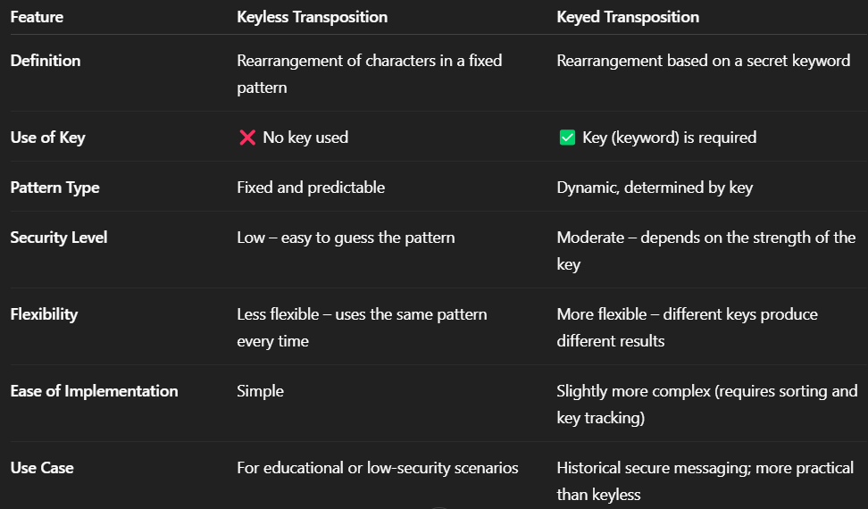

*Steganography :-
Steganography is the practice of concealing information. It involves hiding data within an ordinary, non-secret file or message to prevent detection. The hidden information is being extracted at the receiving end. Often, steganography is combined with encryption to add an extra layer of security for the hidden data. With the help of Steganography, we can hide any digital content virtually like text, image, videotape, etc.
The first step in steganography is selecting a cover medium which is the file or message that will carry the hidden data. Common cover media include: images, audio files, video files or text files.
Sometimes before embedding, the secret message is encrypted to add an additional layer of security.
The secret message is hidden using one of the several techniques:
LSB (Least Significant Bit): Hides data by altering the least significant bit of each byte, commonly used in images and audio.
Frequency Domain: Embeds data in frequency components (like DCT or FFT) instead of raw pixels or samples.
Bit Planes: Conceals data in higher-order bit layers of an image, offering better security and reduced visibility.
The modified data is embedded into the cover medium and the resulting file is known as stego-object.
The receiver of the stego-object decrypts it.

